The Epagneul Breton Foundation, Inc.
To Foundation Volunteer —
Karin Lee-Fournier
After searching unsuccessfully for an exclusively Epagneul Breton calendar, Karin Lee-Fournier decided to create her own 2019 calendar and offer it to other admirers of the breed. “I purchased a pup from Ed Smith (of Smith’s Epagneul Bretons) and read about this scholarship fund and knew if I did this project, I would want it to benefit the Joyce Smith Memorial Scholarship Fund,” Karin said.

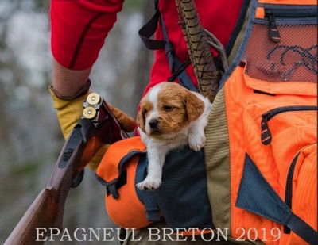
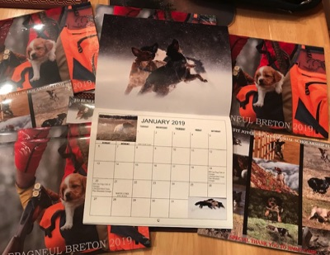

Karin solicited photos from Epagneul Breton owners and photographers, and compiled a stunning representation of the breed for the calendar, from photos of dogs performing in the field to a puppy carried in the back pocket of a hunting vest. Karin expressed gratitude to the EB community that came together to produce the calendar, but her devotion and hours of effort brought it to fruition. Proceeds from the calendar raised nearly $1,000 for the scholarship fund, and EB enthusiasts across the country are now proudly displaying their calendars in 2019.

The Epagneul Breton Foundation, Inc., and others involved with the Joyce Smith Memorial Scholarship Fund sincerely appreciate Karin’s thoughtfulness and dedication.
Special thanks is also extended to photographer Jimmy Cobb for his generous assistance.

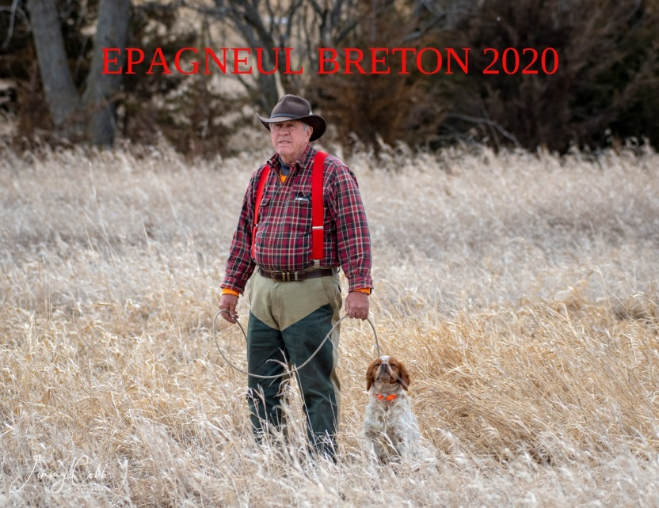
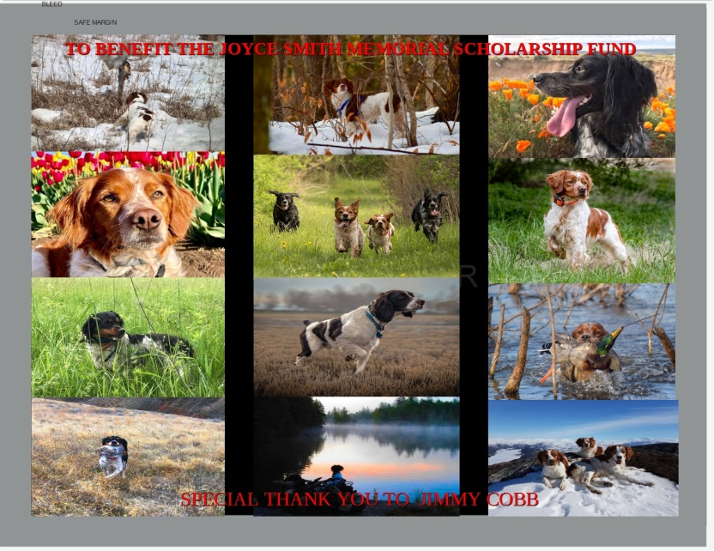
FOLLOW THE FACEBOOK GROUP: EPAGNEUL BRETON CALENDAR 2020
EMAIL: FRENCHBRITTANYCALENDAR@AOL.COM

